🧪 LAB: Change EC2 Instance Type & Validate CPU, Memory, Downtime

🎯 Lab Objective
- Create EC2 with t2.micro
- Check CPU & Memory
- Change instance type to:
  - t2.small OR
  - t3.micro
- Validate CPU & Memory changes
- Confirm whether downtime is required

🔹 Naming Convention
Resource | Name
EC2 | studentname-vm
Key Pair | studentname-key
Security Group | studentname-sg

🚀 STEP 1: Launch EC2 (t2.micro)
Go to:
AWS Console → EC2 → Launch Instance
Configuration
Setting | Value
Name | studentname-vm
AMI | Amazon Linux 2
Instance Type | t2.micro
Key Pair | studentname-key
Security Group | studentname-sg
Inbound Rules | SSH (22) from My IP
Click Launch
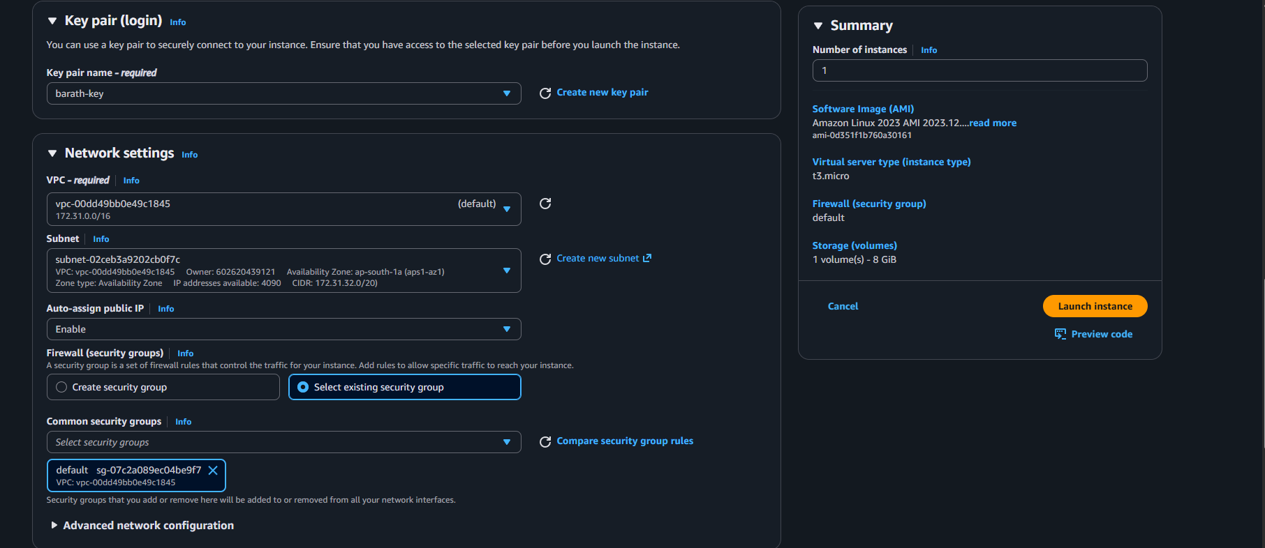

🔹 STEP 2: Connect to Instance
ssh -i studentname-key.pem ec2-user@<public-ip>
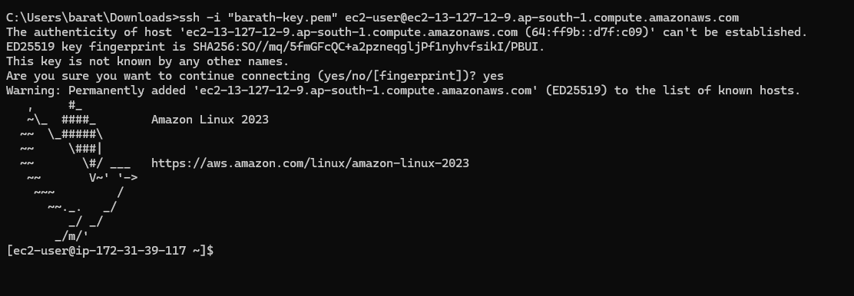

🔹 STEP 3: Check CPU Details
lscpu
OR simple:
nproc
Expected output for t2.micro:
Resource | Value
vCPU | 1
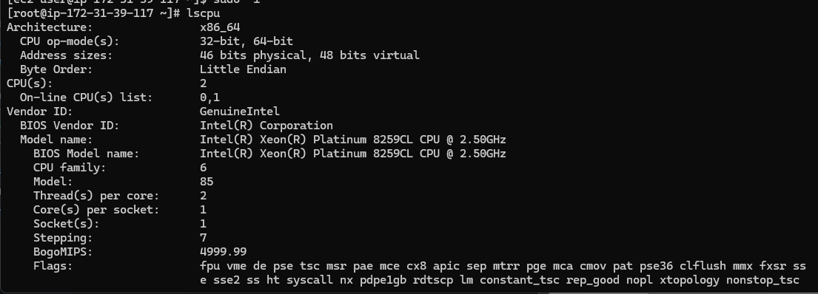
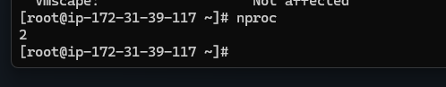

🔹 STEP 4: Check Memory
free -h
Expected output:
Resource | Value
Memory | 1 GiB
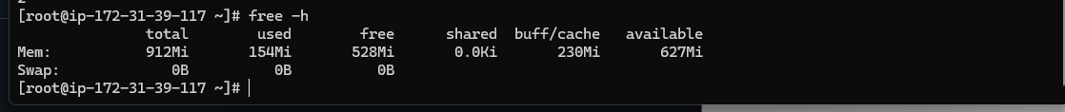

📊 Baseline Result (t2.micro)
Instance Type | vCPU | Memory
t2.micro | 1 | 1 GiB

🔴 STEP 5: Stop the Instance (Required)
Go to:
EC2 → Instances → Select studentname-vm
Click:
Instance State → Stop
Wait until state = Stopped
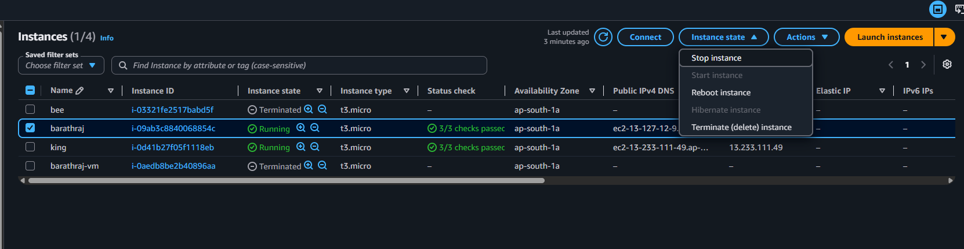

❓ Is Downtime Required?
✅ YES
Instance must be stopped before changing instance type.
During this time:
- SSH will not work
- Application will be unavailable
This is planned downtime

🔹 STEP 6: Change Instance Type
While instance is stopped:
Actions → Instance Settings → Change Instance Type
Choose one:
Option 1: t2.small
- 1 vCPU
- 2 GiB RAM
OR
Option 2: t3.micro
- 2 vCPU
- 1 GiB RAM
Click Apply
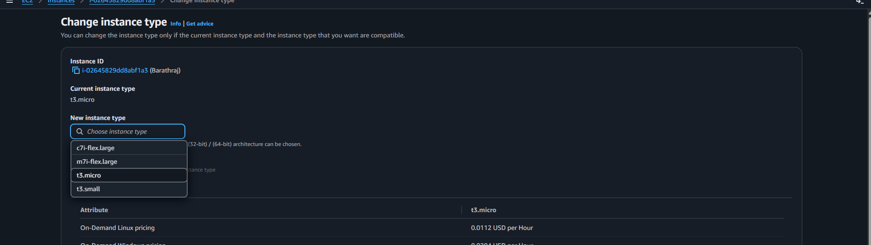

🔹 STEP 7: Start Instance
Instance State → Start
Wait until status checks = 2/2 passed

🔹 STEP 8: Validate CPU Again
SSH again:
ssh -i studentname-key.pem ec2-user@<public-ip>
Check CPU:
nproc

🔹 STEP 9: Validate Memory Again
free -h
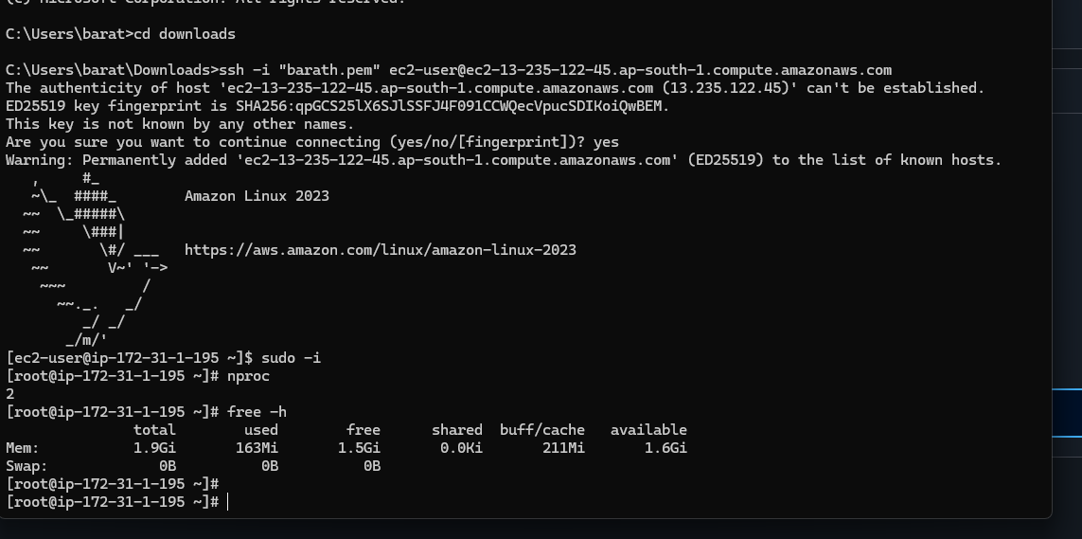

📊 Expected Results
If Changed to t2.small
Resource | Value
vCPU | 1
Memory | 2 GiB

If Changed to t3.micro
Resource | Value
vCPU | 2
Memory | 1 GiB

🔎 Validate Downtime Using Uptime
uptime
It will show recent boot time → proves instance restarted.

🔹 Optional: Check Instance Type from Metadata
curl http://169.254.169.254/latest/meta-data/instance-type
It will return:
t2.small
OR
t3.micro

🧠 Important Observations
Question | Answer
Is downtime required to change instance type? | ✅ Yes
Can change while running? | ❌ No
Data lost? | ❌ No (EBS persists)
Public IP changes? | ✅ Yes (if not using Elastic IP)

🏆 Real-World Concept
This is called:
👉 Vertical Scaling (Scaling Up/Down)
Instead of adding more servers (horizontal scaling), we increase CPU or Memory of same VM.

📌 Final Comparison
Instance | vCPU | RAM
t2.micro | 1 | 1 GiB
t2.small | 1 | 2 GiB
t3.micro | 2 | 1 GiB

